

EuroGlaces Current Best Practices Guidance Document for
Packaging Minimization of
Ice Cream on Sticks

Version 29 January 2026

Disclaimer:

This document is intended solely as a current best practice guidance for manufacturers to design packaging for ice cream on sticks.

Legal requirements on packaging minimization are to be found in art.10 of the Packaging and Packaging Waste Regulation Regulation, as published in the Official Journal of the European Union (EU OJ) on 22 January 2025. According to art. 10, compliance date is on 1st of January 2030.

This document may change following publication of any secondary legislation or Commission’s guidance on the implementation of the PPWR.

This best practice guidance document does not replace good regulatory interpretation of the law.

Introduction
Article 10 of the Packaging and Packaging Waste Regulation (PPWR) stipulates that packaging should be designed so that its weight and volume is reduced to the minimum necessary to ensure its functionality.
Ice cream products vary significantly in form, and manufacturers strive to use the least packaging possible, while ensuring:

- Food safety and hygiene
- Preservation of product integrity
- Provision of essential consumer information
- Functional requirements such as cold chain maintenance and handling.

Ice creams on sticks are a particularly common format. They typically consist of a portion of frozen ice cream on a wooden stick and enclosed in a flow-wrapped film.
The packaging must provide a protective barrier while being carefully minimized in size and weight, within manufacturing constraints.
Despite appearing to leave "extra space" between the product and the film, each element of packaging is designed so that the product reaches the consumer in a perfect condition.
Three technical parameters determine packaging dimensions:
- Dimension of the product: most products will have variability in their dimensions, e.g. variability of coating shapes and stick insertions. The variability in the products is compensated for by the size of the packaging.

- The length of the packaging: The this is the length of the packaging film that wraps one ice cream stick to ensure the product does not get crushed during packing.

- The width of the roll of the packaging film: this is the dimension that wraps around the product where the target wrapper width aligns with the maximum width of the product, especially in uneven shaped products.

Each parameter is calibrated to use the minimum amount of material necessary, while meeting machinery and product handling requirements.

Below we’ll be illustrating some examples on these three aspects
1. Length of the packaging film
This is the length of film used to wrap one unit of ice cream, and it’s determined based on:
- Product height and length
- Machine-specific sealing needs (e.g. crimper widths)
- Space required for film sealing at both ends
Example Calculation Formula:
Cut Length = (Product Height ÷ 0.86603) + Total Crimper Width + Product Length
0.86603 factor relates to the diagonal profile of the product passing through the forming area of the packaging machine.

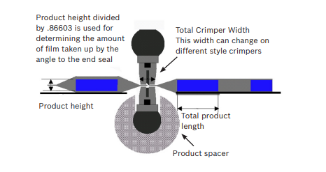
Source: Bosh Guide to Flow-Wrapping
Total product height  Source: Bosh Guide to Flow-Wrapping |   Total product width  Total product length
2. Reel Width (Film Width)
The reel width wraps the film around the product from top to bottom. The calculation accounts for:
- Product width and height
- Fin seal roller height
- Clearance needed for tracking and sealing
Example Calculation Formula:
Reel Width = 2 × (Product Width + Product Height + Fin Seal Roller Height + 5mm)
The 5mm margin allows for deck-plate clearance and consistent film tracking across rollers.
Common Fin Seal Roller Heights: 6 mm, 9 mm, 15 mm
These, together with tracking margin, determine the fin-seal area, which is minimized while maintaining seal integrity.
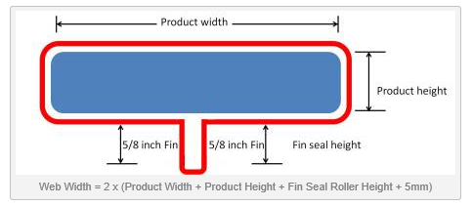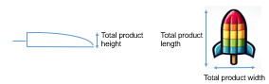
Source: Bosh Guide to Flow-Wrapping

3. Former Size
The former is the shaping mechanism that prepares the film around the product prior to sealing. Its size depends on the cross-section of the ice cream.
- For unstable products (varying shapes/sizes):
Allow ~6.35 mm clearance around the product
- For stable products (uniform shape):
Allow ~3.175 mm clearance
Example Calculation Formula:
Film Width = 2 × Inside Height + 2 × Inside Width + 31.75 mm
(The 31.75 mm accounts for the fin seal overlap.)
These clearances ensure packaging integrity and prevent product damage, particularly with chocolate-coated varieties prone to chipping.

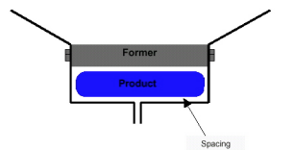
Source: Bosh Guide to Flow-Wrapping

The examples above show that all necessary steps are taken to minimize packaging volume as much as possible. Nevertheless, while a small air gap between the film and ice cream on stick may be visible, it serves key purposes:
- Prevents film from sticking to or damaging the coating
- Compensates for product shrinkage during freezing
- Allows for consistent sealing and wrapping by high-speed machines
This space is not excess but rather a functional design choice rooted in technical and safety requirements.

Conclusions
Ice cream manufacturers are continuously innovating to meet sustainability and waste challenges and reduce the environmental footprint of their packaging.
Packaging minimization has long been a core element of EuroGlaces members’ strategies, and their prime goal is to ensure ice cream products reach the consumers in the best conditions for hygiene, product safety, and damage-free.
EuroGlaces’ members will continue to follow legislative updates and provide additional information accordingly.

Regulation (EU) 2540 of the European Parliament and the of the Council of 19 December 20245 on packaging and packaging waste, amending Regulation (EU) 2019/1020 and Directive (EU) 2019/904, and repealing Directive 94/62/EC, Regulation - EU - 2025/40 - EN - EUR-Lex
Bosch_Guide-to-Flow-Wrapping: https://lms.bbs1-kl.de/pluginfile.php/4762/mod_workshop/intro/Bosch_Guide-to-Flow-Wrapping.pdf

